Workbook 2

Sets, Venn Diagrams, and Probability
Some calculations, too
16. Solve for x without a calculator!

17. Slips of paper numbered 1 through 15 are placed in a box. What is the probability that the first one drawn is a multiple of 2?

What is the probability that the second one drawn is a multiple of 2?
18. You want to call your buddy, but can’t remember the last 2 digits of the phone number. You dial any 2 last. What is the probability that you get the right phone number?
19. In one day a hot dog stand sells 200 dogs. If 75% of them are ordered with onions and 30% of them are ordered with sauerkraut, and 20% of them have neither, how many have both condiments?

20. If is a complex number and the same complex number squared is a purely imaginary number, what do we know about a and b?
21. Which function is modeled by this table?

x | y
−7 | −10
−2 | −5
3 | 0
8 | 5

22. A square piece of flooring is missing from a rectangular floor. The rectangular floor is 2x by 5x. The flooring has side length . Write an equation that describes this situation. First draw a picture, then figure out the equation.

23. A pipe with thick walls has been sliced. The cross-sectional area of the annulus is represented by square meters.

The cross-sectional area of the open area inside the annulus is square meters.

What is the total cross sectional area? Evaluate it for x = 2.

24. At Debbie’s Diner 2 eggs + 1 slice of bacon is $2.87. Two pieces of bacon and 3 eggs is $4.87. How much is one slice of bacon?
25. Given, AB is congruent to AC and the m∠BCD is 109°. What is the m∠CAB?

26. What is the equation for this graph?

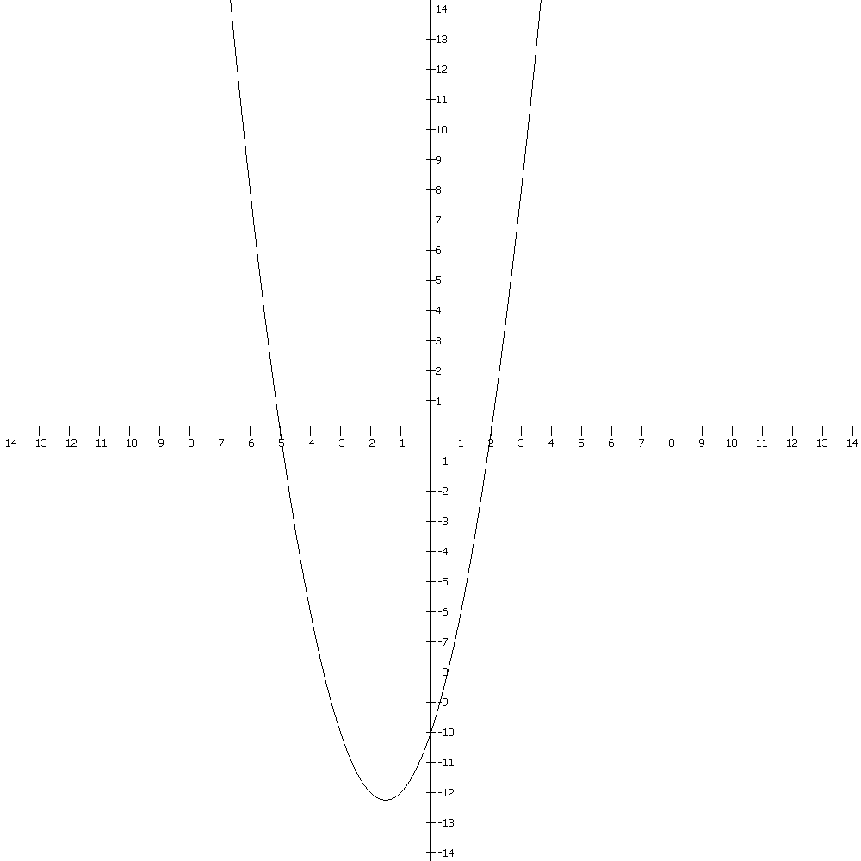

27. A salesman drove 480 miles from Pittsburgh to Hartford. The next day he returned the same distance in 30 minutes less time than his original trip up took, because he increased his average speed by 4 mph. Find his original speed.

28. Given 2 cylinders that are similar solids. What is the definition of a similar solid?

Cylinder A has a radius of 2 and a volume of 20π.
Cylinder B has a height of 10.

Find the volumes of the 2 cylinders. The volume of a cylinder = .

29. A stanine is listing of 9 measurements along the horizontal axis under a standard normal curve.

Sketch a standard normal curve.

The percent area under the curve from the far left to the first stanine is 4%, then 7%, 12%, 17%, then 20%, 17%, 12%, 7%, and finally 4% from the last stanine out to infinity on the right.

The corresponding % of data for each stanine are 4, 11 23, 40, 60, 77, 89, 96

Which area shows a measurement that is unusually uncommon? The standard deviation measurements from the mean are at 68%, 95%, and 99%. How do these fit into the stanine measurements?

30. Two cards are draw from a deck without replacement. What is the probability of drawing a diamond?
21.

